Transcribe

Tanisha Singhai, Shruti Kanungo, Srashti Gupta, Vaishnavi Tiwari

Computer Science Department, Acropolis Institute of Technology and Research Indore, M.P, India

# Abstract:

## People visiting different places often face difficulties in communication due to language barrier. This creates a need for text extraction applications. So this proposed application provides a new idea to the people to translate the other language text into their known language. In this paper we propose an android application that contains three from for translation by input text, voice, and image processing. It is selected by needs of user who can’t manually type the text. It also depicts the process of requirement specification to build the application.

1. **Keyword:**

Transcribe, Image translation, Android, Translation.

# Introduction:

Transcribe is an application which will be used to convert text from one language to another. This application is made to solve a real-world problem. The problem recognized was that people do not know all the languages that they may hear or read. To solve this problem, we searched for existing solutions. We found solutions but they could be better. Hence, we tried to come up with a better solution.

TRANSCRIBE is an android based application which is capable of scanning the image either from the gallery or from the camera. It converts the text from the image into the required language. It can also covert the text

we type into different language and produce the output into a voice form. It is also used to give input in a voice form and produce output through speaker i.e., speech to text translation.

This application can be used by any common man whose requirement is to convert text from one language to another. There is a basic requirement to this application which an android mobile along with android version 4.0.

# Literature Survey

Varied applications based on different technologies have been introduced to solve the problem of text translation. Launched in 2006, biggest name that came forward for this purpose is Google translator with over 100 languages. The translator though still has major loopholes from credibility to security. Also the API for Google translator id paid.

Apart from this I Translate voice 3, Text Grabber, Say Hi, Microsoft translator, Way go and My Lingo are some existing solutions. These systems but tends to fail when it comes to provide a solution that requires only one application for Voice, Text and Image inputs.

Existing text extraction systems are available online which do not recognize all the characters properly. If the image resolution is low these systems do not recognize the characters. Already existing system needs to be more effective**.**

The system we provide ‘transcribe’

magnificently would be able to translate the

image input from any android phone having camera and connectivity. The integration of image processing in the translation application offers user to translate directly without the need to type as it might be possible that the user do not possess enough knowledge to put to words for translation.

The project is developed using android studio IDE. The application contains three steps. 1. Take a photo image of the unknown language text which you want to translate (either handwritten or printed material), 2. Tesseract is an open-source Optical Character Recognition (OCR) technology, which is used to extract the text from the image then Google API and YANDEX API is used for translation of language.

The paper is made of three sections: First discusses the biggest entrant in this area and other existing solutions, second tells the key features to be installed in the system. The experimental output, conclusions and future enhancements are further discussed in the last section of the article.

## Research Methodology

The Transcribe is designed to be used as a text extraction system for the benefits of user and effective translation. The application is successfully able to translate the text inputs, voice inputs and image inputs by processing into 7 embedded languages. Numerous languages are still to be added for the better translation purposes and user needs.

Android applications are widely used and it is easiest to have all three translation methods in one application instead of having three. The feasibility of the system is analyzed by comparing following factors of existing system with proposed system:

**Effort:** As compared with the existing system the proposed system will require less effort and better environment.

**Time:** It is less time consuming due to the limit which is fixed in the proposed system.

**Result Generation:** In this system the result is generated easily and quickly.

## Process

The computer programming stage is the processing stage as the application has to be made computer understandable. It is an important stage where the defined procedures are transformed into control specifications by the help of a computer language. Coding of the application does this. Java language and XML was used to convert the specifications and features of the app into certain program. This program is nothing but a series of computer instructions.

The phases of development are:

* 1. Platform: Android, XML, Java and SQLite
  2. Referred websites: Geeks for geeks, android programming basics by Udacity

## Result

This application has the capability to effectively translate the provided text with the correct articulated meaning. This application would be beneficial for people travelling to different countries for personal purposes and also to the students for any kind of information gathering. It is also good for learning purposes as the language efficiently translates complete sentences.

## Conclusion

The conclusion of the paper suggests that if the application will be put to use it would be of good use for varied users. With adding more languages and synonym feature after thorough study the usability of the app can be improved.

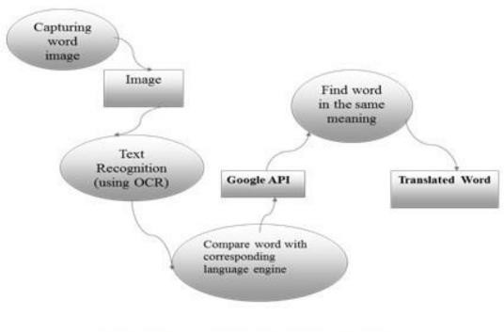The project is further extendable and we aim to include Personal chat box with voice chatting and text chatting. This application can also describe the traffic sign boards.

## References

**https://developer.android.com/reference**